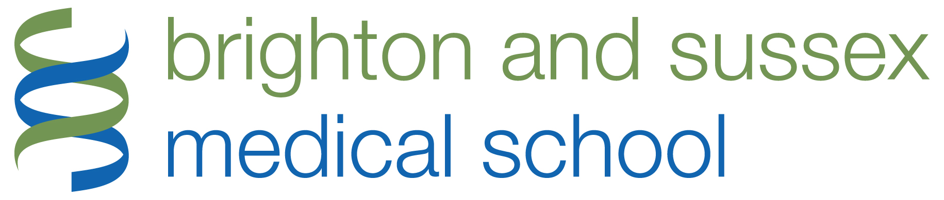
Brain Visiting Lecturer
MINI-SYMPOSIUM PROGRAMME
Generic Disease Mechanisms in Motor Neurone Disease and other Neurodegenerative Disorders
Friday 23 June 2017
Chowen Lecture Theatre, Brighton and Sussex Medical School (BSMS), Teaching Building, University of Sussex, Falmer
PROGRAMME
08.15 – 09.00 | Registration – Coffee and croissants
09.00 – 09.15 | Welcome: Professor Malcolm Reed, Dean, BSMS; Professor Leon Lagnado, Director, Sussex Neuroscience
09.15 – 11.00 1. Intracellular transport and trafficking
Chairs: Professor PN Leigh, BSMS / Professor Claudio Alonso, Sussex Neuroscience
09.15 – 09.45 | Axonal Transport and Neurodegeneration | Dr Majid Hafezparast, Sussex Neuroscience
09.45 – 10.15 | Defective axonal transport of mitochondria in neurodegenerative disease | Dr Kurt De Vos, University of Sheffield
10.15 – 10.45 | Role of myosins in autophagy and neurodegenerative disorders | Dr Folma Buss, University of Cambridge
10.30 – 11.00 | General discussion
Coffee break and poster session (PhD students, Sussex Neuroscience and University of Southampton)
11.15 – 13.00 2. Models and mechanisms
Chairs: Dr Majid Hafezparast, Sussex Neuroscience / Professor Leon Lagnado, Sussex Neuroscience
11.15 – 11.45 | Mouse modelling of motor neurone disease | Professor Elizabeth Fisher, Institute of Neurology, UCL
11.45 – 12.15 | Chick embryo modelling of ALS | Professor Sarah Guthrie, Sussex Neuroscience
12.15 – 12.45 | Understanding the role of microglia in Alzheimer’s disease | Dr Diego Gomez-Nicola, University of Southampton
12.45 – 13.00 | General discussion
Buffet lunch and poster session (PhD students, Sussex Neuroscience and University of Southampton)
14.00 – 16.00 3. Experimental medicine strategies in neurodegeneration
Chairs: Professor Mara Cercignani, BSMS / Professor John Atack, Sussex Drug Discovery Group
14.00 – 14.30 | Propagation of pathology in ALS: insights from neuroimaging | Professor Martin Turner, University of Oxford
14.30 – 15.00 | The role of cognitive and behavioural changes in MND as phenotypic biomarkers | Dr Marwa Elamin, BSMS
15.00 – 15.30 | I believe in MIROCALS…? | Professor Nigel Leigh, BSMS
15.30 – 16.00 | General discussion
Tea break (PhD students, Sussex Neuroscience and University of Southampton)
The Brain Lecture (open lecture)
16.15 – 17.15 | Brain visiting lecture  (Supported by The Guarantors of Brain) | Professor Dame Pamela Shaw FMedSci, SITraN, University of Sheffield
Inauguration of MND Care and Research Network
Wine and refreshments

