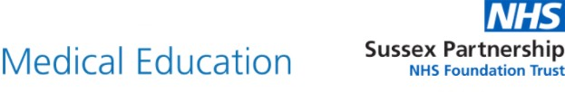

Certificate of Attendance

This is to certify that

Attended the Mind-Brain-Body Symposium 19th October 2022