|  |  |
| --- | --- |
| Hands with gloves in a laboratory using a syringe on research equipment  **Department of Clinical and Experimental Medicine Away Day**  24th November 2022 | Agenda booklet  Details of Itinerary and Speakers  Olivia Cottington  Departmental Administrator |

A very warm welcome to the department of Clinical and Experimental Medicine away day, a networking event designed to promote and strengthen collaborative research links between university and hospital-based members of the department. The theme of today is ‘taking research from bench to bedside’, and the presentations will hopefully give an insight into some of the exciting, impactful and diverse research projects going on in our department. Today we are able to incorporate presentations from only a small number of all of the researchers within CEM, but we intend to make this an annual event, with different speakers every year, and hope that this will encourage new and exciting collaborations across the two sites. To this end we have also included a talk on the Academic Clinical Fellow pathway as we feel that this is an excellent opportunity for researchers across the sites to collaborate as supervisors of these enthusiastic junior researchers. Finally, we have used this event to update you all on the Research Excellence Framework, Teaching Excellence Framework and Knowledge Exchange Framework and our requirements, as a department, for these.

Please do use the lunch and refreshment breaks as a networking opportunity and we hope that you will find the event both inspiring and helpful towards your current and future projects here at BSMS.

**Basic Itinerary**

**09:00-16:00**

09:00-09:45

Morning greetings, teas & coffees

09:45-11:05

Session 1

11:05-11:35

Mid-morning break for refreshments

11:35-12:50

Session 2

12:50-14:00

Break for lunch

14:00-15:30

Afternoon session

15:30-16:00

Conclusions & Afternoon Refreshments

**09:45-11:05**

**Session 1**

**Chaired by Professor Sarah Newbury**

**09:45-09:50 Introduction from both Professor Andrea Pepper & Professor Somnath Mukhopadhyay**

* **Professor Somnath Mukhopadhyay,** Chair in Paediatrics at the Royal Alexandra Children’s hospital, Joint Head of the Department of Clinical and Experimental Medicine.
* **Professor Andrea Pepper,** Professor of Cancer Biology, Joint head of Department for Clinical and Experimental Medicine, Deputy director of student support; UK CLL Forum Executive Committee

**09:50-10:05 ‘Equality and Diversity in the CEM Division’ delivered by Professor Heike Rabe**

* **Professor Heike Rabe,** Professor of Perinatal Medicine and Honorary consultant neonatologist

**10:05-10:20 'Building a Circular Economy for Healthcare Products’ delivered by Professor Mahmood Bhutta**

* **Professor Mahmood Bhutta,** Chair in ENT at UHS Foundation Trust

**10:20-10:50 ‘Should we Care about REF?’ delivered by Professor Chris Pepper & Dr Simon Mitchell**

* **Professor Chris Pepper,** Professor of Cancer research & RM Phillips Chair in Experimental Medicine
* **Dr Simon Mitchell,** Senior Lecturer in Cancer Research

**10:50-11:05, ‘Impact case 1: Elimination Hepatitis C - Making Dreams a Reality’ Delivered by Professor Sumita Verma**

* **Professor Sumita Verma,** Professor of Hepatology

**11:35-12:50**

**Session 2**

**Chaired by Professor Chris Pepper**

**11:30-11:50 ‘Impact case 2’ Presentation delivered by Professor Dame Lesley Fallowfield**

* **Professor Dame Lesley Fallowfield,** Professor of Psycho-oncology and Director of the Sussex Health Outcomes Research & Education in Cancer (SHORE-C) group.

**11:50-12:05 ‘Hypertension in the Very Elderly / Prevention of ADR’ delivered by Professor Chakravarthi Rajkumar on behalf of General Medicine**

* **Professor Chakravarthi Rajkumar,** Chair of Geriatric and Stroke Medicine, Associate Director for Early Career Research Development

**12:05-12:20 ‘CEM contribution to teaching and TEF at BSMS’ delivered by Dr Tom Levett to discuss TEF**

* **Dr Tom Levett,** Senior Lecturer in Medicine and frailty & Director of undergraduate teaching and Learning.

**12:20-12:35 ‘Haemato-Oncology at BSMS’ Delivered by Professor Andrea Pepper**

* **Professor Andrea Pepper,** Professor of Cancer Biology, Joint head of Department for Clinical and Experimental Medicine, Deputy director of student support; UK CLL Forum Executive Committee

**12:35-12:50 ‘Scientific Validation and Utilisation of Extended Reality (Virtual Reality, Augmented Reality and the Metaverse) in Surgical and Medical Education and Implications for Global Health’ delivered by Professor Jag Dhanda**

* **Professor Jag Dhanda,** Honorary Professor & consultant Oral and Maxillofacial/Head and Neck Surgeon

**12:50-14:00**

**Lunch, Poster viewing & informal networking with Communications team**

**Poster 1. ‘Investigating the effect of exoribonuclease activity on the stability and translation of specific transcripts during the cellular stress response’**

Hope Haime, Ben Towler, Mark Smales and Sarah Newbury.

**Poster 2. ‘Identification of circulating non-coding RNA biomarkers for diagnosis and prognosis of human diseases’**

Greig Joilin,Yella Martin, Sarah K. Smalley, Amy L. Pashler, Benjamin P. Towler, Christopher I. Jones, Anthony Metcalfe, Martin R. Turner, Nigel Leigh, Majid Hafezparast and Sarah F. Newbury.

**BSMS Communications team, available for help with website queries & photos**

* **Matt Bemment,** Digital communications officer
* **Jemma Jones,** Communications assistant

**14:00-15:30**

**Afternoon Session**

**Chair by Professor Somnath Mukhopadhyay**

**14:00-14:15, ‘Biomedical Ethics Research at BSMS’ delivered by Professor Bobbie Farsides on Biomedical Ethics**

* **Professor Bobbie Farsides,** Professor of Clinical and Biomedical Ethics

**14:15-14:30 ‘My clinical academic journey: from medical school to PhD’ delivered by Dr Eleni Ladikou**

* **Dr Eleni Ladikou,** PhD Clinical Fellow in Hematology

**14:30-14:50, ‘Rheumatic disease: pathophysiology and potential treatments’ delivered by Dr Lisa Mullen to discuss Osteoarthritis & inflammation**

* **Dr Lisa Mullen,** Senior Lecturer in Biochemistry

**14:50-15:05 ‘Personalised Medicine in Children's Allergy - quo Vadis?’ delivered on behalf of the Paediatrics department by Professor Somnath Mukhopadhyay & Dr Elaney Yousef**

* **Professor Somnath Mukhopadhyay,** Chair in Paediatrics at the Royal Alexandra Children’s hospital, Joint Head of the Department of Clinical and Experimental Medicine.
* **Dr Elaney Yousef,** Lecturer in Medical Education

**15:05-15:20, Presentations delivered by Professor Florian Kern: ‘Identifying T-cell target specificity’ & ‘Introduction to KE and HEIF funding’.**

* **Professor Florian Kern,** Foundation Chair (Honorary Consultant) in Immunology

**15:20-15:30 Questions & conclusions**

**15:30-16:00**

**Afternoon refreshments & networking**

**Speaker Bios**

**Professor Andrea Pepper**

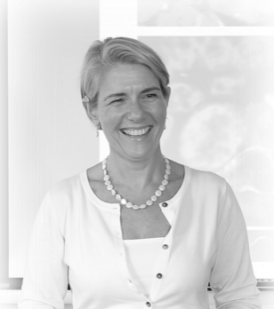

Andrea is a Professor of Cancer Biology and laboratory-based research scientist who runs a Leukaemia and Lymphoma research team at Brighton and Sussex Medical School (BSMS) alongside her husband Prof. Chris Pepper and Dr. Simon Mitchell. She originally trained as a biomedical scientist at St. Thomas’s hospital in London and then at King’s College Hospital. In 1996 she moved to King’s College London University as a research scientist and completed her PhD on Acute Myeloid Leukaemia (AML) in 1999. Since then, she has worked predominately on Chronic Lymphocytic Leukaemia (CLL) but also Follicular Lymphoma and lately, Diffuse Large B-cell Lymphoma and AML again. In 2017 she moved to BSMS where the Pepper/Mitchell research teams are rapidly expanding following grant awards from the MRC, Blood Cancer UK, Sussex Cancer Fund, UKRI and Leukaemia UK.

The focus of Andrea’s research, and talk today, is a brief overview of the current ‘Pepper team’ projects. These include modelling the tumour microenvironment, tumour cell migration and the identification and testing of novel therapeutic targets. She will include the Pepper team research on the role of TLR9 in the pathology and migration of CLL cells and targeting tumour cell adhesion in AML. Andrea and Chris are highly collaborative researchers and Andrea will also talk briefly about some of the novel drugs being tested in the lab and how collaboration with the Mitchell team, and their mathematical modelling skills, has helped inform wet lab experiments.

Andrea currently sits on the executive committee of the UKCLL forum alongside her key CLL clinical collaborator, Dr Rosalynd Johnston. As she is profoundly deaf herself, Andrea is passionate about supporting BSMS students and staff with disabilities. To this end she relishes her roles as a member of the BSMS disability working group and as deputy director of student support.

**Professor Bobbie Farsides**

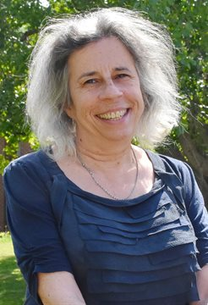

Bobbie joined Brighton and Sussex Medical School as Professor of Clinical and Biomedical Ethics in 2006. She had previously held posts at the Centre of Medical Law and Ethics, King’s College London (Lecturer/Senior Lecturer 1996-2006) and the Department of Philosophy, Keele University (Lecturer 1986-96). She is a graduate of the London School of Economics (B.Sc Econ Government) where she also studied for her PhD under the late Professor Sir Maurice Cranston.

Professor Farsides has been involved in developing the academic field of Bioethics for over thirty years. Whilst at Keele she was part of the team that established innovative master’s programmes which continue to this day, and whilst at King’s she was part of the team delivering their highly successful MA in Medical Law and Ethics. As the Ethics team has grown at BSMS the opportunity arose to develop a new postgraduate offering and in 2021 BSMS will be launching its MA in Contemporary Bioethics.

Since joining BSMS Professor Farsides has been able to expand her activities in relation to global health issues and she is an active member of the Global Health Bioethics Network. She has supervised doctoral projects in The Gambia, Ethiopia and now in China, and has strong links to the ethics and public engagement teams in all the Welcome Trust Major Overseas project sites.

As a long-standing member of faculty Professor Farsides sees an important part of her role as offering mentorship and support to junior colleagues, and she is an enthusiastic and committed mentor to a number of colleagues within BSMS, partner universities and beyond. She was Deputy Chair of the BSMS Research Ethics and Governance committee for ten years and served as Deputy Director, and then Director of Student Support.

**Professor Chakravarthi Rajkumar**

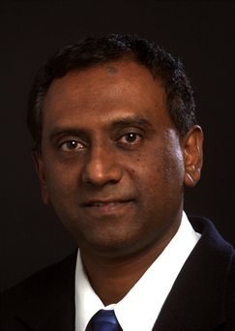

Professor Rajkumar (Raj) was appointed in January 2005 as the Chair of Geriatric and Stroke Medicine, Brighton and Sussex Medical School, and is one of the Consultant Stroke Physicians at University Hospitals Sussex in Brighton. He is also Associate Director for Early Career Research Development in the Local Clinical Research Network (Kent, Surrey and Sussex), part of the National Institute of Health Research (NIHR).

Professor Rajkumar has been actively involved in research in the field of Geriatrics and Stroke medicine. Current research interests include clinical trials in the very elderly, hypertension, vascular compliance and adverse drug reactions. He has published over 350 abstracts, peer reviewed papers and book chapters in journals including *NEJM*, *The Lancet*, the *BMJ* and *JAMA*.

**Professor Chris Pepper**

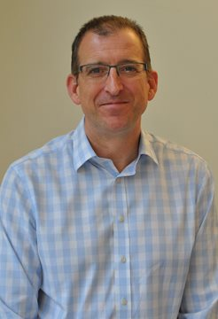

Prof Chris Pepper gained his PhD in medicinal chemistry from the Welsh School of Pharmacy in 1993. Since then his research career has been primarily focused on one disease, chronic lymphocytic leukaemia (CLL). He has published more than 100 research papers, as well as numerous reviews and editorials, and has consistently secured grant funding from major sources including Leukaemia & Lymphoma Research (now Bloodwise), Cancer Research UK and the Association of International Cancer Research. His research has made a number of notable contributions to the field of CLL and is internationally recognized as demonstrated by sustained contributions to the world literature in high impact factor journals including papers in *Leukemia, Blood, Journal of Clinical Oncology, Cancer Research, Clinical Cancer Research, Nature Communications* and *Nature Genetics*. In addition, he is an author of eight global patents and the co-founder of a Cardiff University spin-out company called TeloNostiX.

**Dr Elaney Youssef**

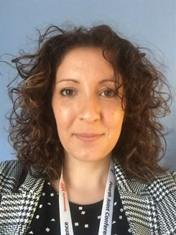

Elaney is a lecturer and health services researcher with an interest in HIV, public health and medical education. She graduated from the University of Southampton with a BSc in Physiology and an MSc in Public Health Nutrition before moving to University Hospitals Sussex NHS Foundation Trust (formerly known as Brighton and Sussex University Hospitals NHS Trust), where she worked in clinical research within the field of HIV and sexual health. In 2015 Elaney received an NIHR Doctoral Research Fellowship to undertake a PhD at BSMS entitled ‘Barriers and facilitators to testing for HIV in people aged ≥ 50 years’, which she completed in 2019. Since that time Elaney has worked as a lecturer at BSMS in the department of Medical Education.

**Dr Eleni Ladikou**

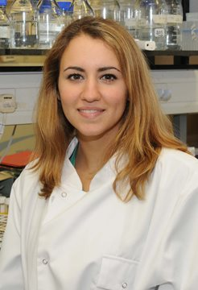

At a very early stage in Eleni's medical training, she committed to a career in clinical academia where she can intermix the rewards of human interaction in clinical medicine with her passion for medical research. Eleni is now a PhD Clinical Fellow investigating the role of Bone Marrow microenvironment in Acute Myeloid Leukaemia. She also works part-time as a clinical trial sub-investigator testing Janssen COVID-19 Vaccine (Johnson & Johnson). She is passionate about academic haematology and translational research. Eleni has successfully completed Core Medical Training, Academic Clinical Fellowship in Haematology and Academic Foundation Programme. Her short-term goal from her PhD research project is to gain more experience in fundamental scientific research and laboratory techniques, learn from field experts and get involved in innovative, high quality medical research. In the long-term, she is committed to developing the skills needed to be a successful academic clinical lecturer and accomplished academic haematologist.

**Professor Florian Kern**

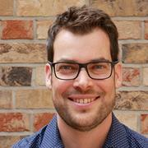

Florian is professor of immunology and pursues mainly laboratory-based translational research. His research team is based at Brighton and Sussex Medical School (BSMS). He also holds a position as honorary clinical consultant in immunology at University Hospitals Sussex (UHS) and is a senior associate director in research & development at JPT Peptide Technologies in Berlin/Germany. He completed a laboratory-based MD thesis in paediatric immunology at the University of Düsseldorf in 1993 before he trained as a medical doctor in nephrology and renal transplantation at Charité University Medicine in Berlin (Germany). In 1995 he moved to the Institute of Medical Immunology where he trained in the laboratory diagnostics of immunological disease and later became director of the clinical immunology laboratory. He completed his ‘Habilitation’ and obtained his ’venia legendi’ in clinical immunology at Charité in 2000 (this is the qualification required to independently represent immunology at a university in Germany). In 2006 he moved to BSMS as ‘Foundation Chair in Immunology’. His work spans basic and clinical immunology with a focus on infectious disease in immunocompromised individuals, tuberculosis, and more lately immune system aging (‘immunosenescence’). His current work focuses on the role of Cytomegalovirus (CMV) in immunosenescence and cardiovascular disease. Florian has driven a number of important technical developments around the use of peptides and peptide pools in studying T-cell responses that are now household methods in many labs worldwide. He also collaborates closely with the school of engineering and informatics (Dr. B. Reus) in the pursuit of new bioinformatic approaches to HLA/disease associations. Florian has co-authored over 85 peer-reviewed original research papers and a range of review articles and book chapters. He is also BSMS director of knowledge exchange.

**Professor Heike Rabe**

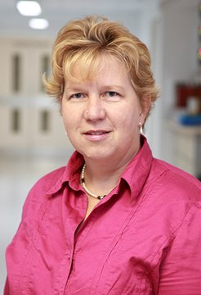

Professor Rabe Heike graduated from the Westphalian-Wilhelms-University of Münster, Germany and completed her clinical training as Paediatrician and Neonatologist and her academic degrees at the Children´s University Hospital of Münster, Germany. In 2002 she was appointed as Consultant Neonatologist and Lead for Research by Brighton & Sussex University Hospitals in order to develop the growing research portfolio within the department. Professor Rabe has been appointed as Professor of Perinatal Medicine by BSMS.

**Professor Jag Dhanda**

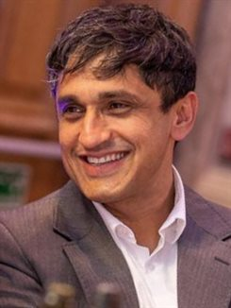

Professor Jag Dhanda is a dual qualified oral and maxillofacial surgeon with a clinical specialty interest in head and neck cancer ablation and reconstruction. He studied dentistry and a BSc (Hons) in Cellular and Molecular Pathology at the University of Bristol. He then went on to complete a medical degree at Barts and the London Medical School and a PhD at the University of Liverpool. He has been the successful recipient of three Royal College of Surgeons of England research fellowships (college, board and specialty) and a CRUK felllowship. Professor Dhanda has been a previous council member for the British Association of Oral and Maxillofacial Surgeons, and he is an elected board member for Faculty of Dental Surgery, Royal College of Surgeons of England. He completed his surgical training in Bristol, London, the West Midlands, and East Grinstead including a trainee interface group advanced head and neck reconstructive fellowship. His NHS surgical practice is limited to advanced head and neck reconstructive procedures including free tissue transfer and microvascular surgery. Professor Dhanda is also a practicing dental implant surgeon in the South East.

**Professor Dame Lesley Fallowfield**

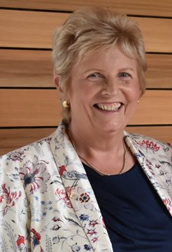

Dame Lesley Fallowfield is Professor of Psycho-oncology at Brighton & Sussex Medical School, University of Sussex where she is Director of the Sussex Health Outcomes Research & Education in Cancer (SHORE-C) group. Dame Lesley originally trained as a nurse at Guy’s Hospital, London but then did a BSc in Experimental Psychology at Sussex. Research for her doctorate examining the perceptual correlates of optic nerve damage in demyelinating diseases was completed at the Universities of Sussex and Cambridge. In 1991 she became the full-time Director of a Psychosocial Oncology Group and was awarded the first European Chair in Psycho-oncology from University College, London in 1997. Her research interests are wide and include the measurement of quality of life in clinical trials of cancer therapy and the training of communication skills for health care professionals in cancer. She has published over 400 papers, many book chapters and 3 text books. She lectures and runs training workshops throughout the world in psychosocial oncology, quality of life assessment and communication skills. She is a Fellow of the UK Academy of Medical Sciences and was made a Dame Commander of the Order of the British Empire in 2016.

**Dr Lisa Mullen**

Lisa’s research interests are in inflammation and innate immunity, particularly in the context of rheumatic diseases such as rheumatoid arthritis, gout and osteoarthritis.  She has a particular interest in cytokine biology and the role(s) of these proteins in the generation and resolution of inflammation. There are two major strands to Lisa’s current research: 1. Understanding the role of oxidative stress and redox regulation in sustaining chronic inflammation in rheumatic disease and 2. Development of engineered cytokines and enzymes as novel therapies for chronic inflammatory disease and osteoarthritis.

**Oxidative stress, redox regulation and inflammation**

Inflammation is often associated with oxidative stress (an imbalance between production of reactive oxygen species (ROS), and their elimination by antioxidants). Research on this topic is focused on identifying redox-regulated signalling molecules that are released under inflammatory conditions and elucidating the role of these molecules in chronic inflammatory disease and on the mechanisms by which ROS might activate inflammatory responses.

**Development of engineered cytokines and enzymes as therapeutics**

Cytokines, growth factors and enzyme inhibitors play a central role in health and disease and as such, have long been recognised for their potential as therapeutics. However, these molecules have a remarkably complex biology and several of their biological attributes have traditionally hampered attempts to use them in therapeutic settings. Latent proteins are engineered using a naturally-occurring ‘shell’ structure known as the latency-associated peptide (LAP) from the cytokine transforming growth factor-β (TGF-β). These engineered molecules are designed to be released from their protective LAP shell only at the sites of disease to increase the half-life in the circulation and avoid side-effects. This delivery technology has potentially wide clinical applications in a number of rheumatic diseases.

**Professor Mahmood Bhutta**

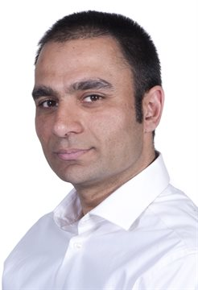

I became an ENT Consultant at University Hospitals Sussex in Brighton four years ago. When I started I was initially purely clinical, but I was fortunate that Brighton and Sussex Medical School (BSMS) wanted to take me on, and recently I have been appointed as chair in ENT surgery.  
  
I have diversified my research interests. In the field of global ear and hearing care I’m a consultant for The World Health Organization (WHO) on their programme on prevention of deafness and hearing loss and have delivered and evaluated training for primary health workers in Uganda, South Africa, Nepal, Fiji and Zambia.  
  
I've also diversified my research into the area of sustainability – which is an area I have worked in for many years. I co-founded the Sustainable Healthcare Group at BSMS, and am Green Lead for University Hospitals Sussex. I am supervising a PhD in carbon footprinting surgical care, have been commissioned to chair a national report in sustainable surgery, and recently chaired a virtual panel discussion at the COP26 World Health Organization Health Pavilion to discuss how the environmental impact of healthcare can be mitigated.

**Dr Simon Mitchell**

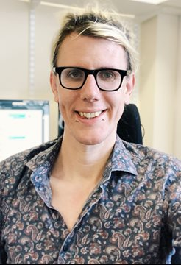

Based on his training in Computer Science and Mathematics, Simon was awarded a Biotechnology and Biological Sciences Research Council (BBSRC) Studentship to pursue a Systems Biology PhD from the University of Manchester. Following his PhD in 2013, and a brief visiting researcher position at the University of Warwick, Simon undertook postdoctoral training in Prof Alexander Hoffmann’s lab at UCLA (USA). He was awarded a UCLA Collaboratory Fellowship to pursue collaborative research and graduate-level teaching for four consecutive years. Simon has published numerous first-author papers (including in Immunity, PNAS and PLOS Computational Biology), multiple reviews, contributed a chapter describing computational modeling approaches to textbooks of laboratory techniques, and contributed to multiple successfully-funded NIH grants. Driven to use systems biology to translate findings from molecular biology to clinical insight, Simon joined BSMS in 2019. Since then, Simon has obtained a Leukaemia UK John Goldman fellowship and a UKRI Future Leaders Fellowship. He is also a member of the NCRI Lymphoma Science Group.

**Professor Somnath Mukhopadhyay**

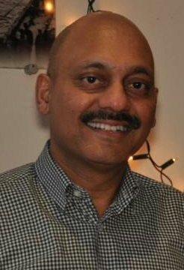

Mukhopadhyay graduated from Kolkata (India) and moved to the United Kingdom to train in paediatrics with the aim of contributing to progress in children’s health through innovative research that leads to direct benefit for society. Alongside training in clinical paediatrics (Kolkata, Merseyside, Bristol, Tayside), he received training in clinical research methodology (Cystic Fibrosis Trust Clinical Research Fellow, University of Bristol Medical School) and laboratory research methodology (Wellcome Trust Advanced Research Training Fellow, University of Dundee Medical School). Subsequently, he joined the University of Dundee Medical School as clinical senior lecturer (honorary consultant) in paediatric respiratory medicine (1997-2007). He was appointed to the Foundation Chair in Paediatrics (honorary consultant), Royal Alexandra Children’s Hospital and the Brighton and Sussex Medical School in 2007.

Mukhopadhyay’s work on the role of skin barrier function and other gene variation in allergy-related diseases has led to a change in the management of paediatric asthma and eczema. This has become life-changing for the most severely affected patients. Research evidence was used to establish a new person-centered clinical approach at the Royal Alexandra Children’s Hospital (Brighton, UK), changing the provision of care for children under 6 months of age. The research is central to the Royal College of General Practitioners’ training on allergy, with 5,489 health professionals trained since 2016. The findings are also a key reference point on the selection of appropriate treatments in the published guidance for health professionals from the National Asthma Council in Australia. Mukhopadhyay has driven academic development in paediatrics at the Royal Alexandra Children’s Hospital and across Sussex.

**Professor Sumita Verma**

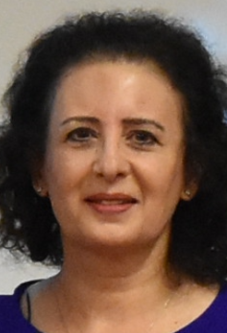

Sumita is Professor of Hepatology (BSMS), and an Honorary Consultant in Hepatology at the University Hospitals Sussex NHS Foundation Trust. She obtained her medical degree from the University of Delhi India, before training as a Gastroenterologist/Hepatologist in Yorkshire, UK. She subsequently worked as an Assistant Professor in Hepatology at the University of Southern California and Johns Hopkins University Hospital, before being appointed as an Academic Hepatologist at Brighton in 2007.

Sumita has developed Hepatology research at BSMS, receiving research funding from the National Institute of Health Research, Dunhill Medical Trust and Gilead Sciences. Her research interests include developing and evaluating novel community models of care for vulnerable adults with liver disease, innovative strategies for management of ascites and autoimmune hepatitis (natural history and outcomes). She is the senior author of the recently published national (2021) (British Society of Gastroenterology) ascites guidelines. In 2014, Royal Sussex County Hospital Brighton was designated as one of the national Hepatitis C center to deliver the national hepatitis C elimination strategy. Sumita is the academic lead of the Sussex ODN, being passionate about achieving hepatitis C elimination. She has authored multiple publications in Hepatology.

**Dr Tom Levett**

Tom gained his medical degree from Cardiff University and completed postgraduate training in Cardiff, London and across Sussex. He undertook his PhD at BSMS where he investigated the prevalence and predictors of frailty in older adults living with HIV.

Tom shares his time between teaching and research for BSMS, as Senior Lecturer in Medicine and Frailty, and the Royal Sussex County Hospital where he is an Honorary Consultant in Elderly Medicine.